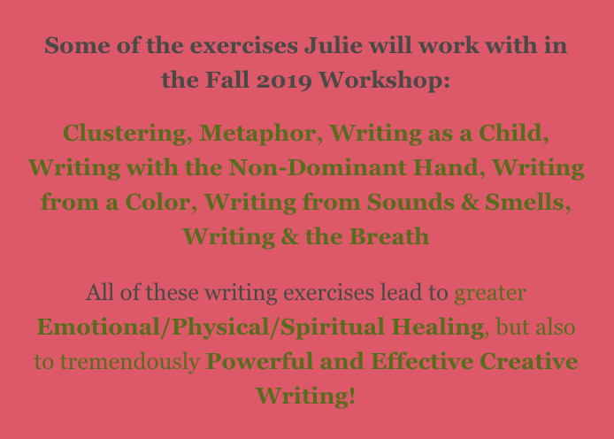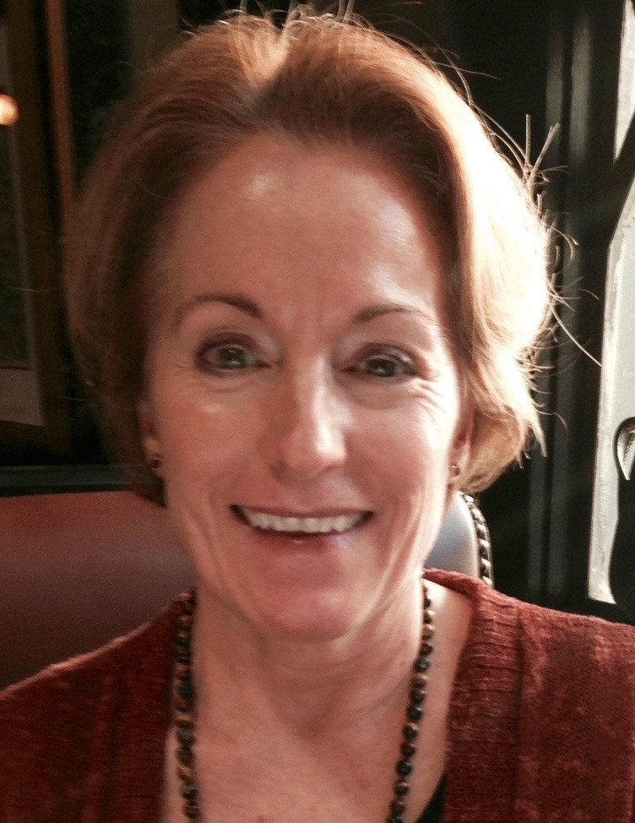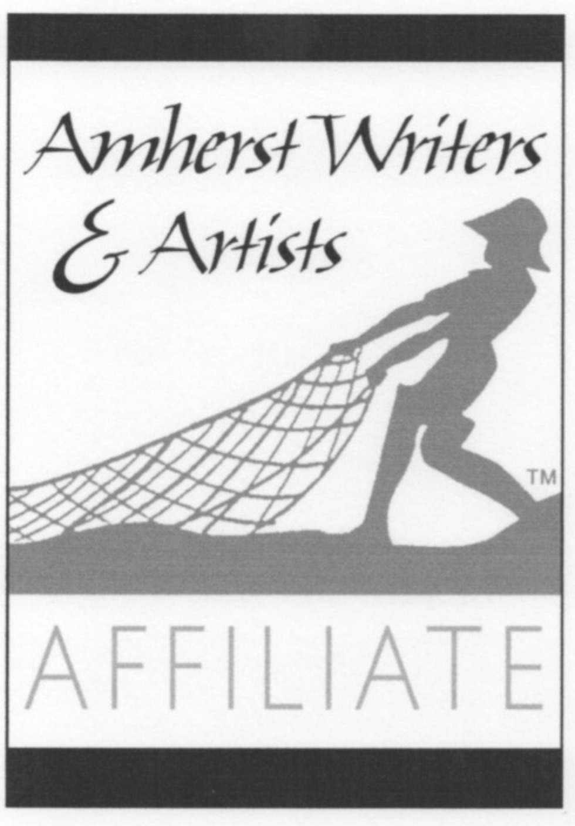

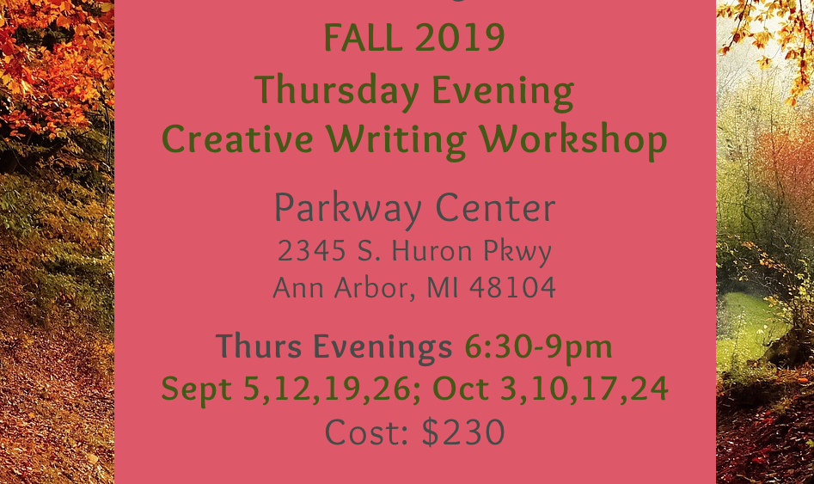

Beginners & Experienced Writers Welcome!

Leader: Julie Mariouw is a published author, english teacher, certified Amherst Writers & Artists workshop leader.

For More Info/To Enroll:

https://www.wellspringwritingworkshops.com/events